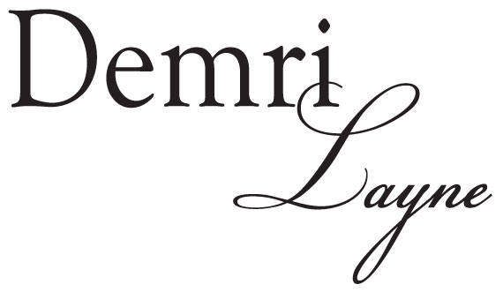

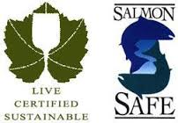
RIESLING
WHITE BLUFFS
COLUMBIA VALLEY
2013

TASTING NOTES
Stone fruit aromas of apricot, nectarine, pear, peach and lemon citrus fills the nose. The palate is full and easy with balanced acidity and a dry, honeyed, peach and pear aftertaste that stays on the palate long after the initial taste. The crisp acidity of this wine makes extended bottle ageing possible and its characteristic light kerosene aromas should be noticed within 2 to 3 years.

GRAPE SOURCE
100% WHITE BLUFFS ESTATE VINEYARD

AWARDS
Outstanding/Best Buy – Great Northwest Wine
Highly recommended/Best Buy—2014 Tastings.com Eco- Friendly Wine Challenge
WINE MAKING NOTES
Harvest Date: October 13, 2013
Brix at harvest: 21.5
Yeast: X5
Fermentation: Grapes were harvested and processed through a mechanical destemmer for increased flavor extraction. The juice was settled with enzymes < 24 hours and then racked to stainless steel tanks where a cool fermentation was performed for fruit retention. Natural yeast-lees settling occurred for 30 days before the wine was filtered and bottled.
Titratable Acidity: 0.67 grams/100ml
pH: 2.95 RS: 2.5%
Alcohol: 12.1% by vol.

1081 Glenwood Road Telephone (509) 266-4449
Mathews Corner FAX (509) 266-4473
Pasco, WA 99301 www.claarcellars.com

